Bismillaahir Rahmaanir Raheem

Information System Management
Course Code: 540229
Book:
1. Rafael C. Gonzalez, Richard E. Woods, Digital Image Processing.
2. Anil K. Jain, Fundamentals of Digital Image Processing.
3. M A Sid-Ahmed, Image Processing Theory, Algorithms and Architectures.

Syllabus:
Introduction to image processing: Representation of image, A basic image processing system, Relationship to human visual system, Example of fields that use digital image processing,
Digital Image Fundamentals: Image formation in the eye, Light and electromagnetic spectrum, Image sensing and acquisition, Image sampling, Image quantization, Some basic relationships between pixels Neighbors of a pixel, Adjacency, connectivity, region, Boundaries, Distance measures.
Image enhancement: Some basic gray level transformations, Histogram processing, Histogram equalization, Histogram matching, Image negatives, log transformation, Power law transformation, Basics of spatial filtering, Smoothing spatial filters, Homomorphic filtering, Correspondence between the spatial and frequency domain filtering.
Image Restoration: A model of the image degradation/ Restoration process, Noise models, Restoration in the presence of noise only spatial filtering.
Color Image processing: Color fundamentals, Color models, the RGB color model, the CMY, CMYK color Model, HIS color Model, Basics of full-color transformation, Color transformations, formulation.
Image Compression: Image compression fundamentals, Coding redundancy, Inter pixel redundancy, Psychovisual redundancy, Image compression models, The source encoder and decoder, The channel encoder and decoder.
Image Segmentation: Edge detection, line detection, point detection, Boundary Detection, Thresholding, Region based segmentation.

Overview:
▪ Chapter-1: Introduction
▪ Chapter-2: Digital Image Fundamentals
▪ Chapter-3: 2D Transformation
▪ Chapter-4: Clipping
▪ Chapter-5: 3D Transformation
▪ Chapter-6: Projection
▪ Chapter-7: Geometric Representation
▪ Chapter-8: Hidden Surface
▪ Chapter-11: Color and Shading Models

Khata-170

Contents:
- Purpose of this course
- Configuration of the course
- Introduction to digital image processing
- Applications of digital image processing

Purpose of this course
- Improve insight for image processing (IP)
- Find proper ways to apply IP techniques to your particular problem
- learn how to read IP papers in proper viewpoints
- Points: representation, model, and process
- Reason: human sensation and physical imaging system

Configuration of the course
- 15(15x3=45) classes are planned
- Time for each class: 60 min
- Student presentation: on good IP papers or specific topics
- Credits: awarded by presentation, midterm examination and final examination

Introduction to digital image processing:
Purpose of Image Processing
- Visualize invisible information
- Image conversion (enhancement, restoration, etc.)
- Image Analysis and object recognition
- Delineate symbolic information from images (OCR, robot vision, etc.)

Why Image?
- Human has too good ability in image processing.
- We can get rich information from the real world from image.
- Constitution of image is mostly influenced by two aspects:
1. human’s visual sensation system and
2. physical system of image formulation.

Medical science এ image processing vastly use হয়।
Mars path finder image → 360 km বেগে ঝড় হয় তাই পানি নেই।
মানুষের face এর angle, distance, color কারো সাথে কারো মিলবে না।
Research grade
Simulation and modeling

- Mathematically আমরা image কে describe করতে পারি।
যদি কোন image কে 1bit দ্বারা প্রকাশ করা হয় তবে ২টি color show করবে।

Image Acquisition is the first process of digital image processing. Being an image it is already in digital form. It is simple and involves preprocessing such as scaling.

Links:
Advanced Digital Image Processing Lecture #l

E:\DCC\Old folder\CSE-170\0-working\0\Library\Academic CSE Books\8\8-4- Optional\8-4-op- Digital Image Processing\IP_BOOK_PDF

E:\DCC\Old folder\CSE-170\0-working\0\Library\Academic CSE Supplements\8\8-4- Optional\8-4-op- Digital Image Processing\CSE-424[IMAGE]

Note making:
E:\CSE-170\User wise\Rafi\8th Semester\4. Image Processing\BOOK Doc

QUESTION:
Chapter-1: Introduction
- Define Image, Digital Image, Digital Image Processing, Pixel
- History of DIP.
- Write down the Application areas of Digital Image Processing.
- Discuss the Fundamental Steps in Digital Image Processing.
- Name the components of an Image Processing system and describe them in short.

Chapter-1
Introduction

CHAPTER SYLLABUS
- Information Systems Management: Introduction
- Information Systems Management in Global Economy
- Strategic Uses of Information Technology
- Strategic Information Systems Planning
- Designing Corporate IT Architecture
- Managing Telecommunications
- Managing Corporate Information Resources
- Technologies for Developing Effective Systems
- Supporting Information-Centric Decision Making
- Supporting IT-Enabled Collaboration
- Supporting Knowledge Work

Outline
• Image, Digital Image, Digital Image Processing, Pixel
• … … …

Question
- Define Image, Digital Image, Digital Image Processing, Pixel.
- Write down the Application areas of Digital Image Processing.
- Discuss the Fundamental Steps in Digital Image Processing.
- Name the components of an Image Processing system and describe them in short.

- DEFINE IMAGE, DIGITAL IMAGE, DIGITAL IMAGE PROCESSING, PIXEL.
Ans:
IMAGE:
Image as a function, f from R² to R.
Any two-dimensional function, f(x, y) that bears information considered as an image. Where x and y are spatial (plane) coordinates.

We can think of an image as a function, f, from R² to R:
f (x, y) gives the intensity at position (x, y)
Realistically, we expect the image only to be defined over a rectangle, with a finite range:
f: [a,b]x[c,d] → [0,1]
A color image is just three functions pasted together. We can write this as a “vector-valued” function:

DIGITAL IMAGE:
Image

DIGITAL IMAGE PROCESSING:
Image

PIXEL:
Image

- DISCUSS THE FUNDAMENTAL STEPS IN DIGITAL IMAGE PROCESSING.
Ans:
Fundamental Steps in DIP:

- Image acquisition is the first process in image processing. Acquisition could be as simple as being given an image that is already in digital form. Generally, the image acquisition stage involves preprocessing, such as scaling.

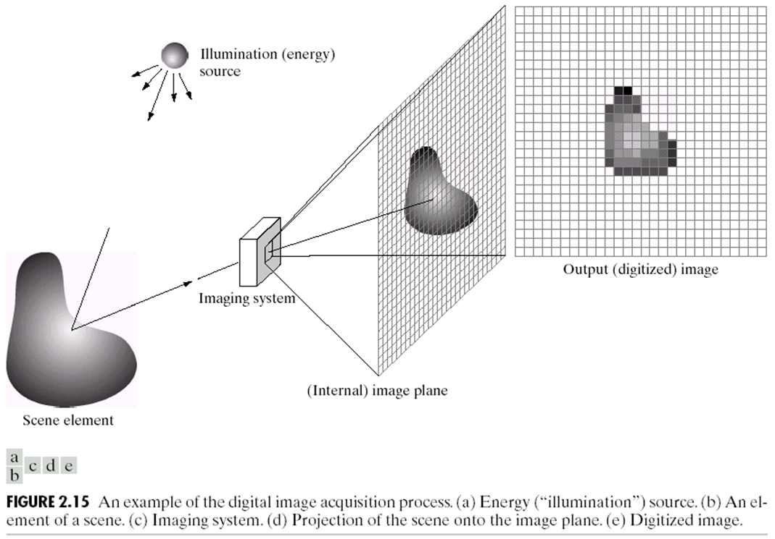

- Image enhancement is the process of manipulating an image so the result is more suitable than the original for a specific application. For example, enhancing X-ray images, enhancing satellite images taken in the infrared band of the electromagnetic spectrum. Enhancement techniques are so varied, and use so many different image processing approaches to represent images visually appealing, interesting, and relatively simple to understand.
- Image restoration is an area that also deals with improving the appearance of an image. However, unlike enhancement, which is subjective, image restoration is objective, in the sense that restoration techniques tend to be based on mathematical or probabilistic models of image degradation. Enhancement, on the other hand, is based on human subjective preferences.
- Color image processing is an area that has been gaining in importance because of the significant increase in the use of digital images over the internet.
- Wavelets are the foundation for representing images in various degrees of resolution. This material can be used for image data compression and for pyramidal representation, in which images are subdivided successively into smaller regions. Ex: Fourier transform etc.
- Compression deals with techniques for reducing the storage required to save an image, or the bandwidth required to transmit it. Ex: Image file extensions, such as the jpg file extension used in the JPEG (Joint Photographic Experts Group) image compression standard.
- Morphological processing deals with tools for extracting image components that are useful in the representation and description of shape.
- Segmentation partitions an image into its constituent parts or objects.
- Feature extraction almost always follows the output of a segmentation stage, which usually is raw pixel data, constituting either the boundary of a region. Feature extraction consists of feature detection (finding the features in an image, region, or boundary) and feature description (assigns quantitative attributes to the detected features). Its parameters are such as scale, translation, rotation, illumination, and viewpoint.
- Image pattern classification is the process that assigns a label (e.g., “vehicle”) to an object based on its feature descriptors. Some methods of image pattern classification ranging from “classical” approaches such as minimum-distance, correlation, and Bayes classifiers, to more modern approaches implemented using deep neural networks.

Define image sampling, image quantization.
Ans:
To create a digital image, we need to convert the continuous sensed data into digital form.
This involves two processes:
- Sampling 2. Quantization

Image Sampling:
The term sampling refers to taking samples. Digitizing the coordinate values is called Sampling.
- Sampling means measuring the value of an image at a finite number of points.
- We digitize the x-axis in sampling.
- It is done on independent variable
- In case of equation y = sin(x), it is done on x variable
- It is further divided into two parts, up sampling and down sampling.

Image Quantization:
Quantization is opposite to sampling. When you are quantizing an image, you are actually dividing a signal into quanta(partitions). So, digitizing the amplitudes is known as Quantization.
- Quantization is the representation of the measured value at the sampled point by an integer.
- It is done on the y-axis.
- On the x-axis of the signal, are the coordinate values, and
- on the y-axis, we have amplitudes.

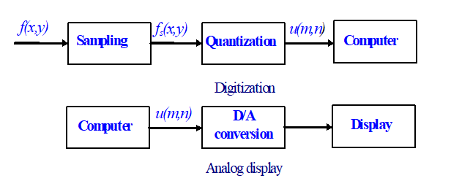
Fig-1: Image sampling and quantization / Analog image display

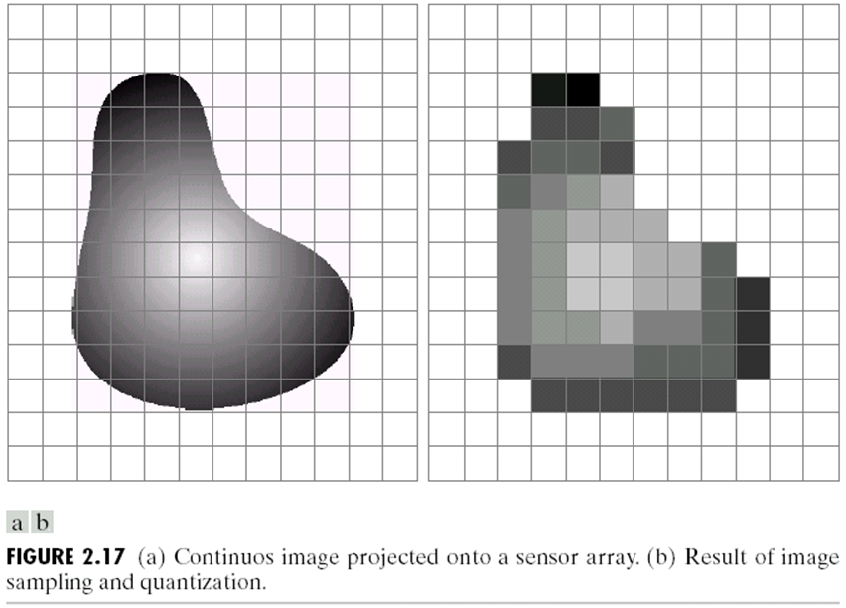

Image Sampling vs Image Quantization
 | Image Sampling | Image Quantization
 | Digitizing the coordinate values is called Sampling. | Digitizing the amplitude values is called Quantization.
 | We digitize the x-axis in sampling. | It is done on the y-axis.
 | It is done on an independent variable. | It is done on dependent variables.
 | Measures the image value at a finite number of points. | Represents the measured value at the sampled point by an integer.

Filtering:
Filtering is a way to change or improve an image by changing the pixel values using a small grid called a filter or mask.

It helps in:
- Removing noise (unwanted dots or grainy look)
- Making edges sharper
- Making the image smoother or blurrier
- Finding lines or corners
Applications of Filtering
- Noise Reduction
- Edge Detection
- Image Smoothing/Blurring
- Image Sharpening
- Feature Extraction

- IMAGE ACQUISITION USING SENSOR STRIPS.
Ans:
IMAGE ACQUISITION USING SENSOR STRIPS:

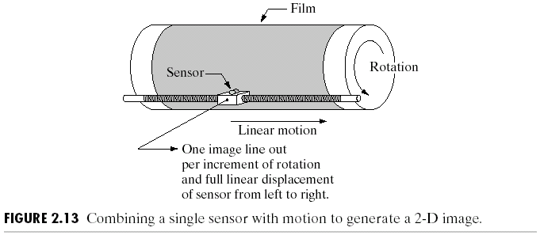

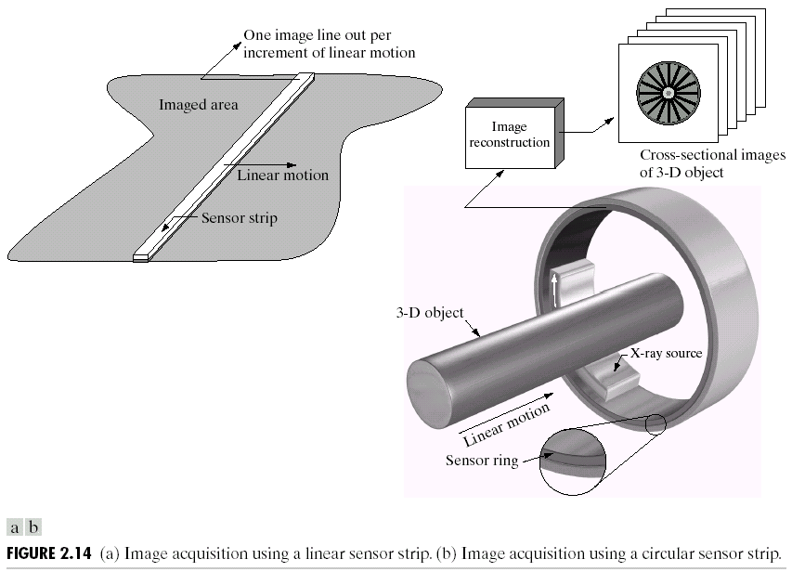

IMAGE ACQUISITION USING SENSOR STRIPS
A geometry used more frequently than single sensors is an in-line sensor strip. The strip provides imaging elements in one direction. Motion perpendicular to the strip provides imaging in the other direction.
- This arrangement is used in most flat bed scanners.
- Sensing devices with 4000 or more in-line sensors are possible.

Sensor strips in a ring configuration are used in medical and industrial imaging to obtain cross-sectional (“slice”) images of 3-D objects.
Homomorphic Filtering
An image f(x,y) can be expressed as the product of illumination and reflectance components.

- DEFINE IMAGE, DIGITAL IMAGE, DIGITAL IMAGE PROCESSING, PIXEL.
Ans:
IMAGE:
Image as a function, f from R² to R.
Any two-dimensional function, f(x, y) that bears information considered as an image. Where x and y are spatial (plane) coordinates.

- DEFINE IMAGE, DIGITAL IMAGE, DIGITAL IMAGE PROCESSING, PIXEL.
Ans:
IMAGE:
Image as a function, f from R² to R.
Any two-dimensional function, f(x, y) that bears information considered as an image. Where x and y are spatial (plane) coordinates.

- DEFINE IMAGE, DIGITAL IMAGE, DIGITAL IMAGE PROCESSING, PIXEL.
Ans:
IMAGE:
Image as a function, f from R² to R.
Any two-dimensional function, f(x, y) that bears information considered as an image. Where x and y are spatial (plane) coordinates.

- DEFINE IMAGE, DIGITAL IMAGE, DIGITAL IMAGE PROCESSING, PIXEL.
Ans:
IMAGE:
Image as a function, f from R² to R.
Any two-dimensional function, f(x, y) that bears information considered as an image. Where x and y are spatial (plane) coordinates.

- DEFINE IMAGE, DIGITAL IMAGE, DIGITAL IMAGE PROCESSING, PIXEL.
Ans:
IMAGE:
Image as a function, f from R² to R.
Any two-dimensional function, f(x, y) that bears information considered as an image. Where x and y are spatial (plane) coordinates.

- DEFINE IMAGE, DIGITAL IMAGE, DIGITAL IMAGE PROCESSING, PIXEL.
Ans:
IMAGE:
Image as a function, f from R² to R.
Any two-dimensional function, f(x, y) that bears information considered as an image. Where x and y are spatial (plane) coordinates.

- DEFINE IMAGE, DIGITAL IMAGE, DIGITAL IMAGE PROCESSING, PIXEL.
Ans:
IMAGE:
Image as a function, f from R² to R.
Any two-dimensional function, f(x, y) that bears information considered as an image. Where x and y are spatial (plane) coordinates.

- DEFINE IMAGE, DIGITAL IMAGE, DIGITAL IMAGE PROCESSING, PIXEL.
Ans:
IMAGE:
Image as a function, f from R² to R.
Any two-dimensional function, f(x, y) that bears information considered as an image. Where x and y are spatial (plane) coordinates.

y
x
Digital Image

Gray
Level

Purpose of IP:
- Visualize invisible information
- Image conversion (enhancement, restoration, etc.)
- Image Analysis and object recognition
- Delineate symbolic information from images (OCR, robot vision, etc.)

Why Image?
- Human has too good ability in image processing.
- We can get rich information from the real-world from image.
- Constitution of image is mostly influenced by two aspects:
- Human’s visual sensation system and
- Physical system of image formulation (মানে camera এর ধরণ, ধাচের উপর নির্ভর করে)

Image Processing
Image processing is a method to convert an image into digital form and perform some operations on it, in order to get an enhanced image or to extract some useful information from it. It is a type of signal dispensation in which input is image, like video frame or photograph and output may be image or characteristics associated with that image. Usually, Image Processing system includes treating images as two-dimensional signals while applying already set signal processing methods to them.

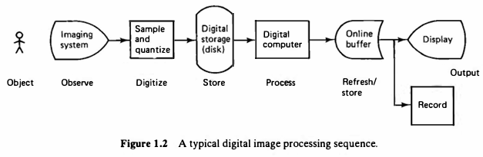
Fig: Block Diagram of a Typical Image Processing Sequence

The Difference between Computer Graphics and Image Processing:
- Computer Graphics: Synthesize pictures from mathematical or geometrical models.
- Image Processing: analyze pictures to derive descriptions (often in mathematical or geometrical forms) of objects appeared in the pictures.
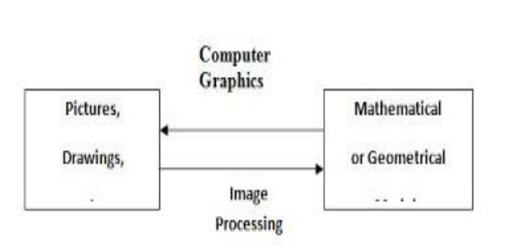

Digital Image:
A digital image is a representation of a two-dimensional image as a finite set of digital values, called picture elements or pixels. Pixel values typically represent gray levels, colors, heights, opacities etc. Digitization implies that a digital image is an approximation of a real scene
When x, y and the amplitude values of $f$ are all finite discrete quantities, then it is called Digital Image.

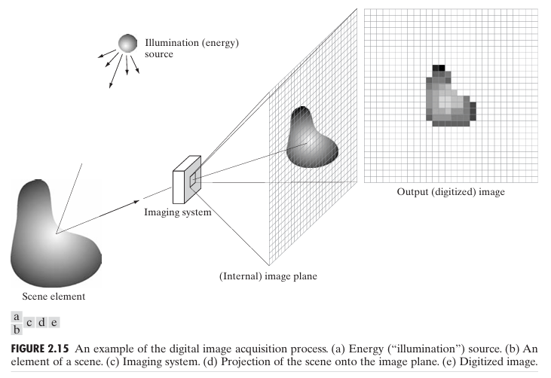

Common image formats include:
- 1 sample per point (B&W or Grayscale)
- 3 samples per point (Red, Green, and Blue)
- 4 samples per point (Red, Green, Blue, and “Alpha”, a.k.a. Opacity)
For most of this course we will focus on grey-scale images.

Digital Image Processing:
Digital Image Processing referred to as to process digital images by means of a digital computer.


Digital image processing focuses on two major tasks
- Improvement of pictorial information for human interpretation
- Processing of image data for storage, transmission and representation for autonomous machine perception
Some argument about where image processing ends and fields such as image analysis and computer vision start.

The continuum from image processing to computer vision can be broken up into low-, mid- and high-level processes—
Low Level Process-
Low Level: Cleaning up the image of some text.
Input: Image
Output: Image
Examples: Noise removal, image sharpening
Mid-Level Process-
Mid-level: Segmenting the text from the background and recognising individual characters.
Input: Image
Output: Attributes
Examples: Object recognition, segmentation
High Level Process-
(/* High level: Understanding what the text says */)
High level: Understanding what the text says.
Input: Attributes
Output: Understanding
Examples: Scene understanding, autonomous navigation

History of Digital Image Processing:
Early 1920s: One of the first applications of digital imaging was in the news-
paper industry
- The Bartlane cable picture transmission service
- Images were transferred by submarine cable between London and New York
- Pictures were coded for cable transfer and reconstructed at the receiving end on a telegraph printer
Ex: Early digital image.

Mid to late 1920s: Improvements to the Bartlane system resulted in higher quality images
- New reproduction processes based on photographic techniques
- Increased number of tones in reproduced images
Ex: Improved digital image, Early 15 tone digital image

1960s: Improvements in computing technology and the onset of the space race led to a surge of work in digital image processing
- 1964: Computers used to improve the quality of images of the moon taken by the Ranger 7 probe. Ex: A picture of the moon taken by the Ranger 7 probe minutes before landing
- Such techniques were used in other space missions including the Apollo landings

1970s: Digital image processing begins to be used in medical applications
- 1979: Sir Godfrey N. Hounsfield & Prof. Allan M. Cormack share the Nobel Prize in medicine for the invention of tomography, the technology behind Computerized Axial Tomography (CAT) scans. Ex: Typical head slice CAT image.

1980s - Today: The use of digital image processing techniques has exploded and they are now used for all kinds of tasks in all kinds of areas
- Image enhancement/restoration
- Artistic effects
- Medical visualisation
- Industrial inspection
- Law enforcement
- Human computer interfaces

Examples:
- Image Enhancement- One of the most common uses of DIP techniques: improve quality, remove noise etc.
- The Hubble Telescope- Launched in 1990 the Hubble telescope can take images of very distant objects.
However, an incorrect mirror made many of Hubble’s images useless
Image processing techniques were used to fix this.
- Artistic Effects- Artistic effects are used to make images more visually appealing, to add special effects and to make composite images
- Medicine- Take slice from MRI scan of canine heart, and find boundaries between types of tissue
  - Image with gray levels representing tissue density
  - Use a suitable filter to highlight edges
  - Figure:
Original MRI Image of a Dog Heart → Edge Detection Image
- GIS- Geographic Information Systems
  - Digital image processing techniques are used extensively to manipulate satellite imagery
  - Terrain classification
  - Meteorology
- Industrial Inspection-
Human operators are expensive, slow and unreliable.
Make machines do the job instead.
Industrial vision systems are used in all kinds of industries.
Can we trust them?
- PCB Inspection-
Printed Circuit Board (PCB) inspection
  - Machine inspection is used to determine that all components are present and that all solder joints are acceptable
  - Both conventional imaging and x-ray imaging
- Law Enforcement-
Image processing techniques are used extensively by law enforcers
  - Number plate recognition for speed cameras/automated toll systems
  - Fingerprint recognition
  - Enhancement of CCTV images
- HCI-
Try to make human computer interfaces more natural
  - Face recognition
  - Gesture recognition
Does anyone remember the user interface from “Minority Report”?
These tasks can be extremely difficult.

Pixel:
A digital image is composed of a finite number of elements, each of which has a particular location and value. These elements are referred to as picture elements, image elements, pels and pixels.
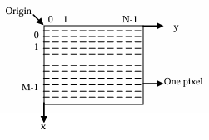

Q. Write down the Application areas of Digital Image Processing.
Ans:
Application areas of Digital Image Processing—
- Gamma Ray Imaging
- X-ray Imaging
- Imaging in the Ultraviolet Band
- Imaging in the visible and Infrared Bands
- Imaging in the Microwave Band
- Imaging in the Radio Band

Q. Discuss the Fundamental Steps in Digital Image Processing.
Or, Key Stages of IP Or, Image Processing Procedures.
Ans:

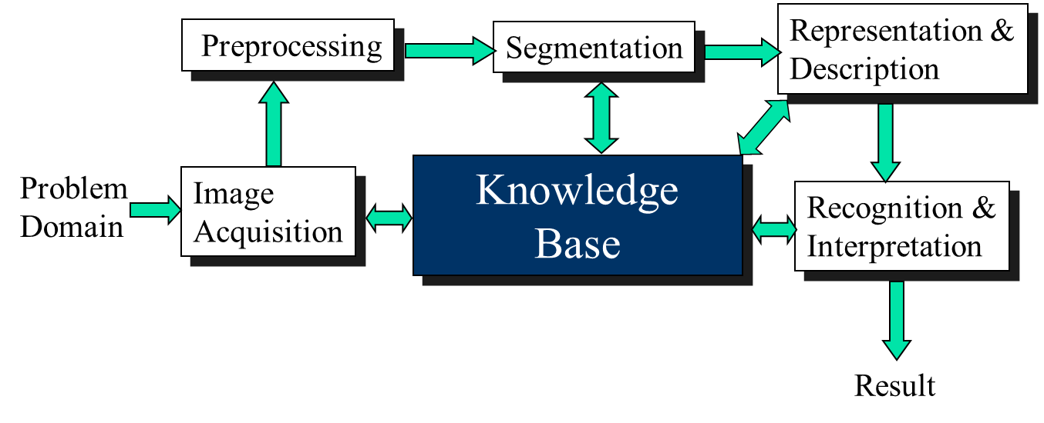
Fig: Fundamental Steps Image Processing Procedures

Fundamental steps in Digital Image Processing:
- Image acquisition
- Enhancement
- Restoration
- Color processing
- Compression
- Morphological processing
- Segmentation
- Representation and description
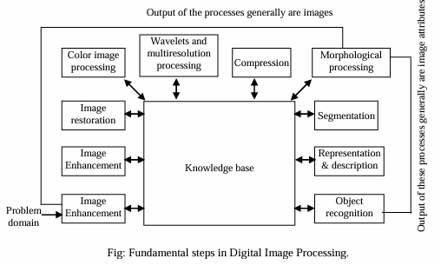

Digital Image Processing Details:

All the methodologies that can be applied to images for different purpose and possibly with different objectives are as follows-
Image acquisition
  - Gave some hints regarding the origin of digital images.
  - Involves preprocessing, such as scaling.

Image Enhancement
- Bring out detail that i obscured, or simply to highlight certain features of interest in an image.
- Represent the image information clearly.
- Subjective.
- e.g., Fourier Transform.

Image Restoration
- Deals with improving the appearance of an image.
- Objective.

Color Image Processing
- An area that has been gaining in importance because of the significant increase in the use of digital images over the Internet.
- Simplifies object identification and extraction from a scene.

Wavelets
- Foundation for representing images in various degrees of resolution.

Compression
- Reducing the storage required to save an image, or the bandwidth required to transmit it.

Morphological Processing
- Extracting image components that are useful in the representation and description of shape.

Segmentation
- Partition an image into its constituent parts or objects.

Representation & Description
- Always follow the output of a segmentation stage, which usually is raw pixel data, constituting either the boundary of a region or all the points in the region itself.
- Description (or feature selection), deals with extracting attributes that result in some quantitative information of interest for differentiating one class of objects from another.

Recognition
- Assigns a label to an object lased on its descriptors.
- There is an interaction between these processing modules and the knowledge base. Knowledge about a problem domain is coded into an image processing system in the form of a knowledge database.

Q. Name the components of an Image Processing System and describe them in short.
Ans:
Components of an Image Processing System
- The basic components comprising a typical general-purpose system used for digital image processing is shown in the figure-
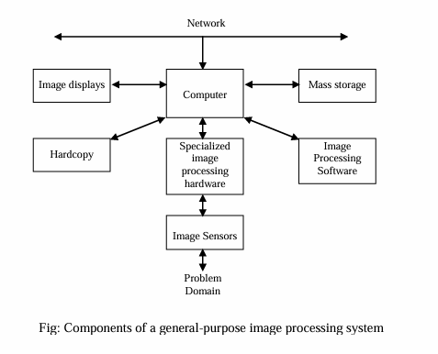

Image Sensors:
Two elements—
- Physical Device- is sensitive to energy radiated by the object.
- Digitizer- is a device for converting the output of the physical sensing device into digital form.
Specialized Image Processing Hardware:
It consists of digitizer just mentioned, plus hardware, that performs other primitive operations such as ALU (performs arithmetic and logical operator in entire image).
Computer:
The computer in an image processing system is a general-purpose computer and can range from one PC to a super computer.
Image Processing Software:
Consists of specialized modules that perform specific tasks.
Mass Storage:
It falls into three principal categories:
- Short term storage for use during processing.
- On-line storage for relatively fast recall.
- Archival storage.
Image Display:
It is used mainly in color tv monitor (preferably flat screen).
Hardcopy: Hardcopy devices for recording images include laser printers, film cameras, heat-sensitive devices, inkjet unit, and digital units.
Networking:
It is almost a default function in any computer system, communicate with remote sites via internet.

Q. What do you mean by image enhancement? What are the techniques to enhance an image?
Ans:
Image Enhancement:
To create a visible image or structure from an invisible image, that is image enhancement. (Image enhancement is a technique to sharpening an image in a visible form.) … … … … …

Chapter 2
Digital Image Fundamentals
Outline
• ?
• ?

Chapter 2.pdf

Questions:
- How an image is formed in the eye?
- How digital images are represented? Explain in brief.
Or, How can you represent an image?
- Express an image formation model
Or, Describe a simple image model
Or, Give a simple image formation model.
- Explain Image sampling and Quantization
Or, Write short notes about Sampling & Quantization.
- Define: (i) 4-neghbors of pixel
(ii) Euclidean distance
(iii) City-block distance
(iv) Chessboard distance

- How an image is formed in the eye?
Ans:
Image Formation in the Eye

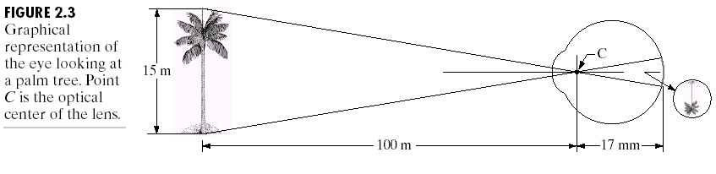
Fig: Graphical representation of the eye looking at a palm tree.

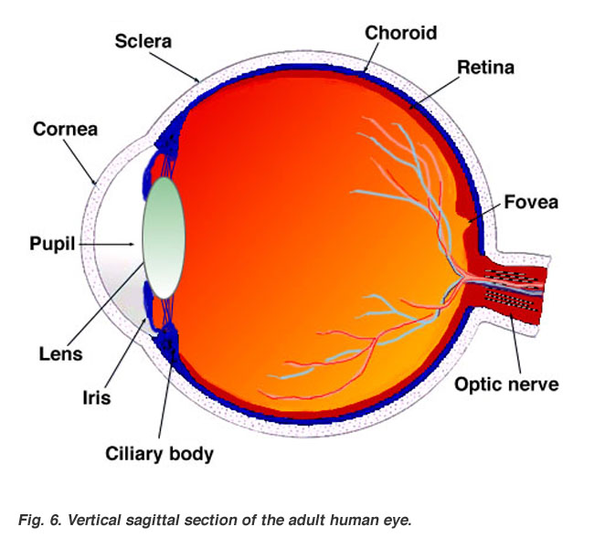
Sagittal section of adult human eye

- In human eye, the radius of curvature of the anterior surface of the lens is greater than the radius of its posterior surface.
- The shape of the lens is controlled by tension in the fibers of the ciliary body.
- To focus on distant objects, the controlling muscles cause the lens to be relatively flattened.
- Similarly, these muscles allow the lens to become thicker in order to focus on objects near the eye.
- The distance between the center of the lens and the retina (called focal length) varies from approximately 17mm to about 14mm, as the refractive power of the lens increases from its minimum to its maximum.
- When the eye focuses on an object farther away than about 3m, the lens exhibits its lowest refractive power.
- When the eye focuses on a nearby object, the lens is most strongly refractive. This information makes it easy to calculate the size of the retinal image of any object.
- e.g.,
The observer is looking at a tree 15m high at a distance of 100m.
If h is the height in mm of that object in the retinal image, the geometry of the above fig yields $\frac{15}{100}= \frac{h}{17}$
⇒ h = 2.55mm
The retinal image is reflected primarily in the area of the fovea, and transformed the radiant energy into electrical impulses that are ultimately decoded by the brain.

- How digital images are represented? Explain in brief.
Or, How can you represent an image?
Ans:
Representing Digital Images

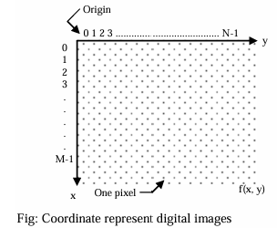

- Assume that an image f(x, y) is sampled so that the resulting digital image has M rows and N columns.
The values of the coordinates (x, y) now become discrete quantities. We use integer values for these discrete coordinates.
Thus, the values of the coordinates at the origin are (x, y) = (0, 0). The next coordinate values along the first row of the image are represented as (x, y) = (0, 1).
- The complete M×N digital image in the following compact matrix form:
$$f\left(x,y\right)=\left[\begin{matrix}f(0,0) & f(0,1) & … & f(0,N-1) \\ f(1,0) & f(1,1) & … & f(1,N-1) \\ … & … & … & … \\ f(M-1,0) & f(M-1,1) & … & f(M-1,N-1)\end{matrix}\right]$$

- The right side of this equation (1) is by definition a digital image. Each element of this matrix array is called an image element, picture element, pixel, or pel.
- A more traditional matrix notation to denote a digital image and its elements:
$A= \left[\begin{matrix}a_{0,0} & a_{0,1} & … & a_{0,N-1} \\ a_{1,0} & a_{1,1} & … & a_{1,N-1} \\ … & … & … & … \\ a_{M-1,0} & a_{M-1,1} & … & a_{M-1,N-1}\end{matrix}\right]$
clearly, aij = f(x=i, y=j) = f(i,j)

So, equation (1) and equation (2) are identical matrices.

- Due to processing, storage, and sampling hardware considerations, the number of gray levels typically an integer power of 2.
L = 2^{k} .......................(3)
The discrete levels are equally spaced and interval is [0, L-1]

- To store a digital image, the number of bits,
b = M ×N×K................. (4)
When M = N
b = N²k
An image can have 2^{k} gray levels, refer to as ‘k-bit image’

- Express an image formation model
Or, Describe a simple image model
Or, Give a simple image formation model.
Ans:
A Simple Image Formation Model
- An image is a two-dimensional function is of the form $f(x,y)$
The value or amplitude of $f$ at spatial coordinates $(x,y)$ is a positive scalary quantity.

- When an image is generated from a physical process, its values are proportional to energy, radiated by a physical source (e.g., electromagnetic waves).
$f(x,y)$ must be non-zero and finite:
i.e., $0<f(x,y)<$ ........................ (1)

- The function $f(x,y)$ may be characterized by two components:
1) The amount of source illumination incident on the scene being viewed
⇒ Illumination, denoted by $i(x,y)$
2) The amount of illumination reflected by the objects in the scene
⇒ Reflectance, denoted by $r(x,y)$

combining two functions as a product to form $f(x,y)$
$f(x,y) = i(x,y) ᴦ (x,y)$ ................(2)
Where, $0< i(x,y) <$ ..................... (3)
and $0 < r (x,y) < 1$ ................ (4)

- Reflectance is bounded by 0 (total absorption)
and 1 (total reflectance)
The nature of i(x,y) is determined by the illumination source
and r(x,y) is determined by the characteristics of the imaged object.
Here, transmissivity is used instead of reflectivity function.

- Typical ranges of $i(x,y)$ for visible light
Illumination source | Condition | Value
sun | clear sunny day  cloudy day  commercial area | 90,000 lm/m²  10,000 lm/m²  1,000 lm/m²
Moon | clear Evening | 0.1 lm/m²

- Typical values of $r(x,y)$
black velvet | 0.01
stainless steel | 0.65
flat-white wall paint | 0.80
silver-plated metal | 0.90
snow | 0.93

- The intensity of a monochrome image at any coordinates (x₀, y₀) the gray level (l) of the image at that point. That is,
l = f (x₀, y₀) .................... (5)
It is evident that l lies in the range
$L_{min}≤l ≤ L_{max}$ ............... (6)
Where, $L_{min}$ be positive
and $L_{max}$ be finite
and, $L_{min} = i_{min} r_{min}$
$L_{max} = i_{max} r_{max}$
- Typical limits for indoor values in the absence of additional illumination
$L_{min}≈10$
and $L_{max}≈1000$

- The interval $[L_{min}, L_{max}]$ is called the Gray Scale.
Numerically, it becomes [0, L-1]
Where l=0 is considered as black
and l = L-1 is considered as white

All intermediate values are shades of gray varying from black to white.

- Explain Image sampling and Quantization
Or, Write short notes about Sampling & Quantization.
Ans:
Image sampling and Quantization
- To create a digital image, we need to convert the continuous sensed data into digital form.
This involves two processes:
Sampling
Quantization

- Fig (a) shows a continuous image $f(x,y)$, that is converted to digital form. An image may be continuous with respect to the x-and y-coordinates, and also in amplitude.
To convert it to digital form, we have to sample function in both coordinates and in amplitude.

Digitizing the coordinate values is called Sampling Digitizing the amplitude values is called Quantization.
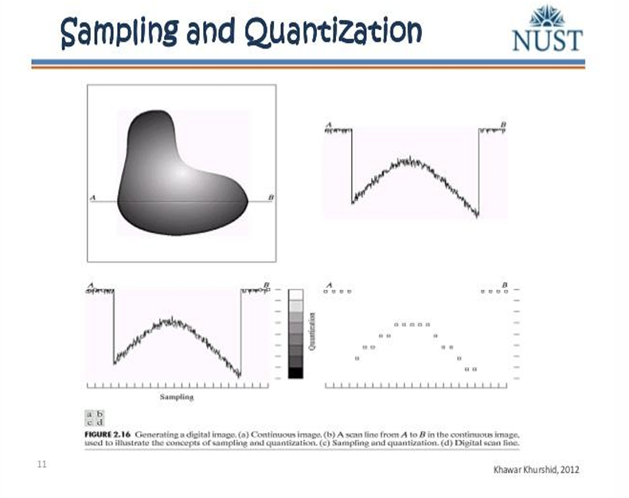
Fig: Generating a digital image (a) Continuous image (b) A scan line from A to B the continuous image, used to illustrate the concepts of sampling & Quantization. (c) Sampling and quantization (d) Digital scan line.

- Sampling
The one-dimensional function shown in fig (b) is a plot of amplitude (gray level) values of the continuous image along the line segment AB in fig (a).

To sample this function, taking equally spaced sampled along line AB, as shown in fig (c). The location each sample is given by a vertical tick mark in the bottom part of the figure.
The samples are shown as mall white square superimposed on the function. The set of these discrete locations gives the sampled function. However, the values of the samples still span (vertically) a continuous range of gray-level values.

- Quantization
In order to form a digital function, the gray-level values also must be converted (quantized) into discrete quantities.
The right side of fig (c) shows the gray-level divided into eight discrete levels, ranging from black to white.

The vertical tick marks indicate the specific value assigned to each of the eight gray levels. The continuous gray levels are quantized simply by assigning one of the eight discrete gray levels to each sample.

The assignment is made of depending on the vertical proximity of a sample to a vertical tick mark. The digital samples resulting from both sampling and quantization are shown in fig (d).

Starting at the top of the image and carrying out this procedure line by line produces a two-dimensional digital image.

- What is 4-neghbors of pixel, Diagonal neighbor of pixel, 8-neighbor of pixel.
Ans:
4-neighbors of Pixel
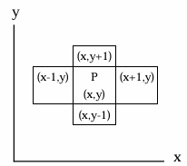
- A pixel p at coordinates (x,y) has four horizontal and vertical neighbors whose coordinates are given by (x+1, y), (x-1, y), (x, y+1), (x, y-1)

This set of pixels, called the 4-neighbors of p, is denoted by N4(P). Each pixel is a unit distance from (x, y), and some of the neighbors of P lie outside the digital image, if (x, y) is on the border of the image.

Diagonal neighbor of Pixel
- The 4-diagonal neighbors of P have coordinates (x+1, y+1), (x+1, y-1), (x-1, y+1), (x-1, y-1) and are denoted by N_{D}(P)
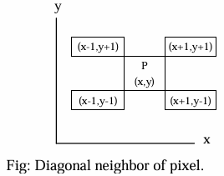

8-neighbors of pixel
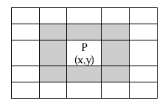
- The 4-neighbors of P and 4-diagonal neighbor of P together, is called 8-neighbors of P, and is denoted by
N₈(P) = (N₄(P)+ N_{D}(P)

- What is connectivity and Binary Image?
Ans:
Connectivity:
Two pixels are said to be connected if they are adjacent and must have following criteria
i) They are neighbor
ii) Their gray-levels are equal.

Binary Image:
If the gray-level treated as where 0 to 125 considered as 0
and 126 to 255 considered as 1
then, this is referred to as Binary Image
- e.g., Let V = {125, 100, 0, 126.................255}

- Explain about adjacency.
Ans:
Types of Adjacency
There are three types of Adjacency:
1) 4-adjacency
2) 8-adjacency
3) m-adjacency

1) 4-adjacency
Two pixels p and q with values from V are 4-adjacent if q is in the set N₄(p).
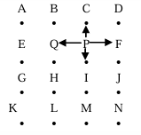
- Let V = {255, 20, 10^{p}, 21^{q}, 100}
∴ N₄(P) = {C, I, F, Q}

2) 8-adjacency
Two pixels p and q with values from V are 8-adjacent if q is in the set N₈(P).
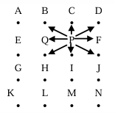
  - Let V = {255, 20^{p}, 25^{p}, 125, 235, 240, 130, 140, 122, 250, 210, 205}
∴ N₈(P) = {B, C, D, Q, F, H, I, J}

3) m-adjacency
Two pixels p and q with values from v are m-adjacent if
i) q is in N₄(p)
or, ii) q is in N_{D} (p) and the set N4(p) n N₄ (q) has no Mixed adjacency is a modification of 8-adjacency.

Limitation of 8-adjacency:
Ambiguities arise when
- create infinite loop
- generate closed path
- generate deadlock

To eliminate these ambiguities, use the following set
N₄(p) n N₄ (q)

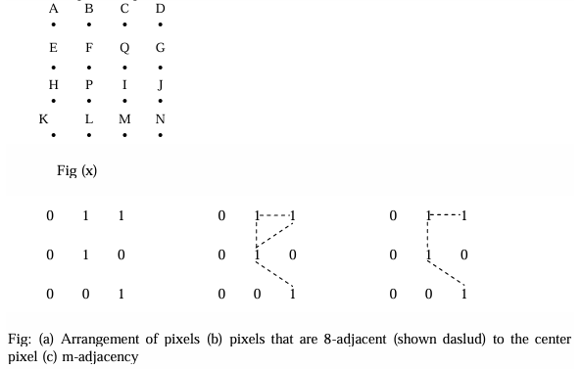

N₄ (p) = {H, L, I, F}
N₄ (q) = {C, F, I, G}

N₄(p) n N₄ (q) = {I, F}; Here I must be removed to avoid looping situation.

- What is Path, closed path, region and boundary?
Ans:
Path
A Path from pixel p with coordinates (x,y) to pixed q with coordinates (s,t) is a sequence of distinct pixels with coordinates
(x₀, y₀), (x₁,y₁),............, (x_{n}, y_{n})
Where (x₀, y₀) = (x,y), (x_{n}, y_{n}) = (s,t), and
pixels (x_{i}, y_{i}) and (x_{i-1}, y_{i-1}) are adjacent for $1≤ i ≤n$.

In this case, n is the length of the path.
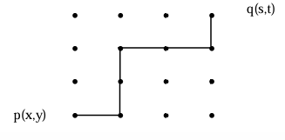

Closed Path
If there is a sequence of distinct n pixels with coordinates
(x₀, y₀), (x₁,y₁), ..............., (x_{n}, y_{n})
and if (x₀, y₀) = (x_{n}, y_{n}), i.e., the start and end is same, called closed path.
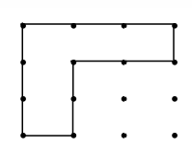

Region
Let R be a subset of pixels in an image.
R is a Region of the image if R is a connected set.
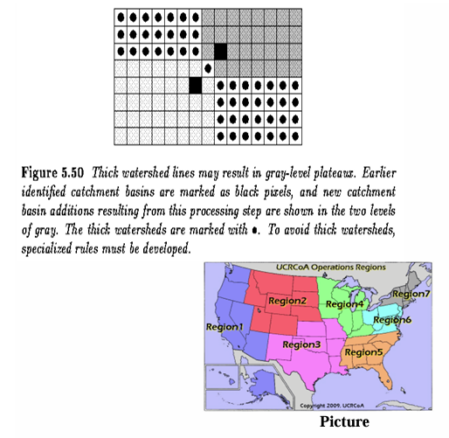
- Here, the pixels neighbors and their gray level are equal

Boundary
Let R be a subset of pixels in an image.
The Boundary (border or contour) of a region R is the set of pixels in the region that have one or more neighbors that are not in R.

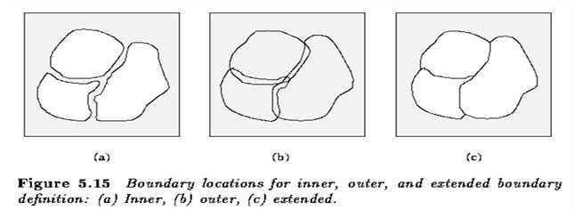

- i.e., The intensity level of the entire image is different from the intensity level of the outside image.

- If R happens to be an entire image,
then its boundary is defined as the set of pixels in the first and last rows and columns of the image.

- Explain Distance function, Euclidean distance, city-block distance, chessboard distance.
Ans:
Distance Function
- For pixels p, q, and z, with coordinates (x,y), (s,t), and (v,w), respectively, D is a Distance Function or metric if
- D (p,q) ≥ 0 (D (p,q) = 0 iff p = q)
- D (p,q) = D (q,p)
- and D(p,z) ≤ D (p,q) + D (q,z)

Euclidian distance
- The Euclidian distance between p and q is defined as
$D_{e}(p,q)=\sqrt{{(x-5)}^{2}+{(y-t)}^{2}}$

- In this approach, the pixels having a distance less than or equal to some value r from (x,y) are the points contained in a disk of radius r centered at (x,y).

D₄ distance/city-block distance
- The D₄ Distance (or city-block distance) between pixels p and q is defined as
$$D_{4}(p,q)=|x-s|+|y-t|$$

- In this case, the pixels having a D₄ distance ≤2 from (x,y) (the center point) form the following contours of constant distance.
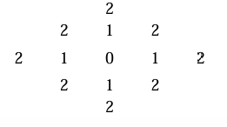
The pixels with D₄ = 1 are the 4-neighbors of (x,y)

D₈ distance/ chessboard distance
- The D₈ distance between pixels p and q is defined as
$$D_{8}(p,q)=max (|x-s|+|y-t|)$$

- In this case, the pixels with D₈ distance from (x,y) less than or equal to some value r from a square centered at (x,y)

- e.g., The pixels with D₈ distance ≤ 2 from (x,y) (the center point) form the following contours of constant distance.
$\begin{matrix}2 & 2 & 2 & 2 & 2 \\ 2 & 1 & 1 & 1 & 2 \\ 2 & 1 & 0 & 1 & 2 \\ 2 & 1 & 1 & 1 & 2 \\ 2 & 2 & 2 & 2 & 2\end{matrix}$

The pixels with D₈ = 1 are the 8-neighbors of (x,y)

Q. Image Sampling vs Image Quantization

Image Sampling | Image Quantization
Digitization of co-ordinate values. | Digitization of amplitude values.
x-axis(time) – discretized. | x-axis(time) – continuous.
y-axis(amplitude) – continuous. | y-axis(amplitude) – discretized.
Sampling is done prior to the quantization process. | Quantization is done after the sampling process.
It determines the spatial resolution of the digitized images. | It determines the number of grey levels in the digitized images.
It reduces c.c. to a series of tent poles over a time. | It reduces c.c. to a continuous series of stair steps.
A single amplitude value is selected from different values of the time interval to represent it. | Values representing the time intervals are rounded off to create a defined set of possible amplitude values.

Chapter 3
Image Enhancement in the Spatial Domain

Outline
•

Chapter 3.pdf

Question:
- What do you mean by Image Enhancement? Write down some techniques involved on it.
- Briefly explain about Image Transformation function.
Or, Write short notes on thresholding.
- What are the basic gray-level Transformation?
i) Image Negative
ii) Log Transformation
iii) Power-Law Transformations.
- What is Histogram Processing? Write down its application.
Or, What do you mean by Histogram of gray levels in an image?
- Briefly explain Histogram Equalization.
- What is Histogram Matching? Discuss the development process of this method.
- Define coefficients.
- Discuss the mechanism of Linear Spatial Filtering.
Or, Explain “convolving a mask with an image”
- What are the uses of smoothing filters and blurring?
- Describe the technique of smoothing spatial filter. Write down Applications of Smoothing filters.
- What are the objectives of sharpening an image?

- What do you mean by Image Enhancement? Write down some techniques involved on it.
Ans:
Image Enhancement:
❑ Image Enhancement refers to accentuation or sharpening of image features such as edges or contrast to make graphic display more useful for display and analysis.
❑ Image Enhancement technique is used to represent the image information clearly.
Image Enhancement Technique:
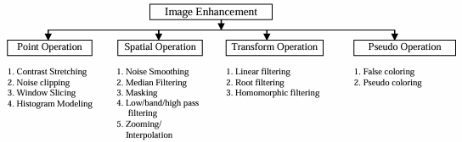

- Briefly explain about Image Transformation function.
Or, Write short notes on thresholding.
Ans:
Image Transformation
❑ The term spatial domain refers to the aggregate of pixels composing an image. Spatial domain methods are procedures that operate directly on these pixels. Spatial domain processes will be denoted by the expression.
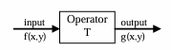
g(x, y) = T [f(x,y)] ....................(1)
Where, f(x,y) is the input image
g(x,y) is the processed image
T is an operator on f, defined over some neighborhood of (x,y).
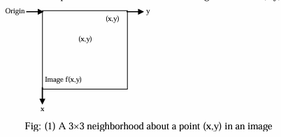
❑ The principle approach in defining a neighborhood about a point (x,y) is to use a square or rectangular subimage centered at (x,y), as shown in fig(1).

The center of the subimage is moved from pixel to pixel starting at the top left corner. The operator T is applied at each location (x,y) to yield the output, g, at that location. The process utilizes only the pixels in the area of the image spanned by the neighborhood.

❑ The simplest form of T is when the neighborhood is of size $1×1$; i.e., a single pixel.
In this case, g depends only on the value of f at (x,y) and T becomes a gray-level (intensity or mapping) transformation of the form
s = T(r) ......................(2)
Where,
r denotes the gray-level of f(x,y) at any point (x,y)
s denotes the gray-level of g(x,y) at any point (x,y)
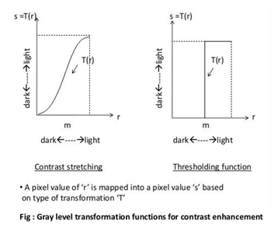
❑ If T(r) has the form shown in fig (2-a), the effect of this transformation would be to
produce an image of higher contrast than the original by darkening the levels below m and brightening the levels above m in the original image This technique referred to as contrast stretching.

In the limiting case shown in fig (2-1), T(r) produces a two-level (binary) image. A mapping of this form is called a Thresholding Function.
❑ Enhancement at any point in an image depends only on the gray-level at that point,
referred to as Point Processing.

- What are the basic gray-level Transformation?
Ans:
❑ Let, for a particular image, the values of pixels, before and after processing is denoted by r and s respectively. These values are related by an expression of the form.
s = T (r)
Where, T is a transformation that maps a pixel value r into a pixel value s.

❑ In gray-level transformation, three basic types of functions are frequently used for image enhancement.
1. Linear (Negative and Identity Transformation)
2. Logarithmic (Log and Invese Log Transformation)
3. Power-Law (nth Power and nth root Transformation)

1. Image Negatives
❑ The negative of an image with gray levels in the range [0, L-1] is obtained by using the negative transformation as shown fig ( ), which is given by the expression.
s = L-1-r................... (1)
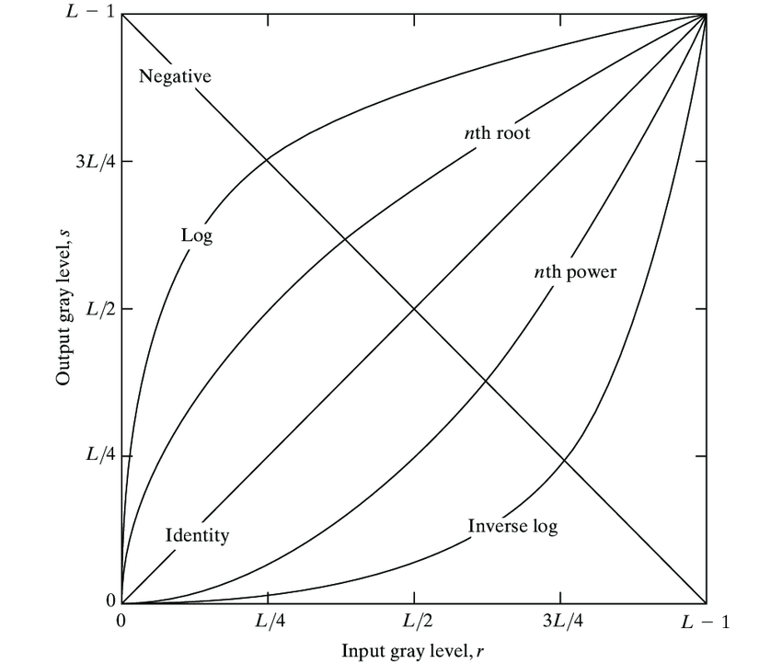
Fig (1) Basic gray-level transformation functions used for image enhancement.

2. Log Transformation
❑ The general form of the log transformation shown in fig (1) is:
$s = c log (1+r) ...................... (2)$
Where, c is a constant
and it is assume that $r ≥0$

❑ The shape of the log curve in fig (1) shows that, this transformation maps a narrow
range of low gray-level values in the input image into a wider range of output levels. The opposite is true of higher values of input levels.

3. Power-Law Transformations
❑ Power-law transformations have the basic form
$s = cr^{π}............................(3)$
Where, c and $π$ are positive constant

❑ Sometimes equation (3) is written as
$s = c {(r + ε)}^{π}$
to account for an offset
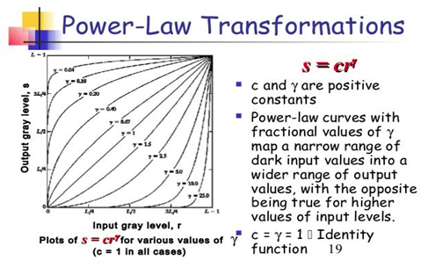
Fig (2) : Plots of the equn s = crπ for various values of ∂ (c=1 in all cases)

❑ From the fig (2), the curves generated with values of r > 1 have exactly the opposite effect as those generated with values of r < 1.
Equation (3) reduces to the identity transformation when c = r = 1

- What is Histogram Processing? Write down its application.
Or, What do you mean by Histogram of gray levels in an image?
Ans:

Page 6
Ch-3.pdf

- Briefly explain Histogram Equalization.
Ans:

- What is Histogram Matching? Discuss the development process of this method.
What is Histogram matching? Discuss the Development process of this method. Alternative Answer of Ques-6 (2nd portion)
Ans:

- Define coefficients.
Ans:

- Discuss the mechanism of Linear Spatial Filtering.
Or, Explain “convolving a mask with an image”.
Ans:

- What are the uses of smoothing filters and blurring?
Ans:

- Describe the technique of smoothing spatial filter.
Ans:

- What are the objectives of sharpening an image?
Ans:

Chapter 4
Image Restoration
Outline
•

Chapter 4.pdf

Chapter 5
Color Image Processing
Outline
•

Chapter 5.pdf

Chapter 6
Image Compression
Outline
•

Chapter 6.pdf

Chapter 7
Image segmentation
Outline
•

Question:
- What do you mean by Huffman coding? Analyze the two steps of Huffman coding with an appropriate example.
Or, Explain the Huffman Coding. (2020, 2014, 2015)
- What do you mean by edge detection? (2015, 2011)
- Write down the Sobel diagonal masks. (2020, 2015)
- Describe the criteria for edge linking. (2015)
- Explain the region growing segmentation with an example. (2015)
- What is image segmentation? (2013)
- Write down the importance of edge detection. (2013)
- Discuss about region-based segmentation. (2014, 2016)
- Define image subtraction, image negative, and gray level slicing. (2012)
- What is image segmentation? Discuss different types of image segmentation techniques. (2020)
- How can you detect a point in an image? (2020)
- Write down the edge linking procedure. (2011)
- Explain the use of motion in segmentation. (2016)
- Write down the line detection algorithm for Horizontal, Vertical, +45°, and -45°. (2011)
- Obtain the Huffman’s code for the following sequence: - (2015)
5 5 5 5 8 8 4 2 7 7 7 2 2
2 2 4 4 7 7 7 7 2 2 2 2 2
2 2 2 2 2 2 2 2 2 2 2 4 4
4
What is average code length with and without compression?

- What do you mean by Huffman coding? Analyze the two steps of Huffman coding with an appropriate example. [2020,2014]
Or, Explain the Huffman Coding. 2015
Answer:
Prefix Codes, means the codes (bit sequences) are assigned in such a way that the code assigned to one character is not the prefix of code assigned to any other character. This is how Huffman Coding makes sure that there is no ambiguity when decoding the generated bit stream.
Let us understand prefix codes with a counter example. Let there be four characters a, b, c and d, and their corresponding variable length codes be 00, 01, 0 and 1. This coding leads to ambiguity because code assigned to c is the prefix of codes assigned to a and b. If the compressed bit stream is 0001, the de-compressed output may be “cccd” or “ccb” or “acd” or “ab”.
See this for applications of Huffman Coding.
There are mainly two major parts in Huffman Coding
1) Build a Huffman Tree from input characters.
2) Traverse the Huffman Tree and assign codes to characters.

Steps to build Huffman Tree
Input is an array of unique characters along with their frequency of occurrences and output is Huffman Tree.
- Create a leaf node for each unique character and build a min heap of all leaf nodes (Min Heap is used as a priority queue. The value of frequency field is used to compare two nodes in min heap. Initially, the least frequent character is at root)
- Extract two nodes with the minimum frequency from the min heap.
- Create a new internal node with a frequency equal to the sum of the two nodes frequencies.
Make the first extracted node as its left child and the other extracted node as its right child.
Add this node to the min heap.
- Repeat steps#2 and #3 until the heap contains only one node. The remaining node is the root node and the tree is complete.
2) Let us understand the algorithm with an example:
character | Frequency
a | 5
b | 9
c | 12
d | 13
e | 16
f | 45
3)

More edit:
Chapter 7.pdf

- What do you mean by edge detection? [2015,2011]
Answer:
We can say that sudden changes of discontinuities in an image are called as edges. Significant transitions in an image are called as edges.
Types of edges
Generally, edges are of three types:
  - Horizontal edges
  - Vertical Edges
  - Diagonal Edges
Detect edges
Most of the shape information of an image is enclosed in edges. So first we detect these edges in an image and by using these filters and then by enhancing those areas of image which contains edges, sharpness of the image will increase and image will become clearer.
Here are some of the masks for edge detection that we will discuss in the upcoming tutorials.
  - Prewitt Operator
  - Sobel Operator
  - Robinson Compass Masks
  - Krisch Compass Masks
  - Laplacian Operator.
Above mentioned all the filters are Linear filters or smoothing filters.

- Write down the Sobel diagonal masks. [2020,2015]
Answer:
The Sobel operator is very similar to Prewitt operator. It is also a derivate mask and is used for edge detection. Like Prewitt operator Sobel operator is also used to detect two kinds of edges in an image:
  - Vertical direction
  - Horizontal direction
Difference with Prewitt Operator
The major difference is that in sobel operator the coefficients of masks are not fixed and they can be adjusted according to our requirement unless they do not violate any property of derivative masks.
Following is the vertical Mask of Sobel Operator:
Chapter 7.pdf

- Describe the criteria for edge linking. [2015,2011]
Answer:
Edge detectors yield pixels in an image lie on edges.
The next step is to try to collect these pixels together into a set of edges.
Thus, our aim is to replace many points on edges with a few edges themselves.
The practical problem may be much more difficult than the idealized case.
  - Small pieces of edges may be missing,
  - Small edge segments may appear to be present due to noise where there is no real edge, etc.
In general, edge linking methods can be classified into two categories:
Local Edge Linkers
-- where edge points are grouped to form edges by considering each point's relationship to any neighboring edge points.
Global Edge Linkers
-- where all edge points in the image plane are considered at the same time and sets of edge points are sought according to some similarity constraint, such as points which share the same edge equation.

- Explain the region growing segmentation with example. [2015]
Answer:
Segmentation divides an image into its constituent parts or objects. Level of subdivision depends on the problem being solved. Segmentation stops an object of interest in an application have been isolated. Segmentation is concerned with dividing an image into meaningful regions. For example, for an air to ground target acquisition system, interest may lie in identifying vehicles on the road.
-segment the road from the image
-segment contents of the road down to objects of a range of size that corresponds to the potential vehicle
-no need to go below this level or segment outside the road boundary

Segmentation algorithm for monochrome images is based on one of the two basic properties of grey level values.
  - Discontinuity
  - Similarity
The segmentation algorithm is pixel oriented. For discontinuity the approaches to partition an image based on abrupt changes in grey level.
The region in the image is a group of connected pixels with similar properties. Each pixel is assigned to a particular object or region.
Region Growing:
Region growing is an approach to image segmentation in which neighboring pixels are
examined and added to a region class if edges are detected.
This process is iterated for each boundary pixel in the region. Adjacent region is found a region merging algorithm is used in which weak edges are dissolved and strong edges are left intact.
Region growing requires a seed, to begin with. Initially, the seed would be a region, but it would be a single pixel. A new segment is grown from the seed by eliminating as many neighboring cells as possible that meet the homogeneity criteria. The resultant segment is then recovered from the process.
A new seed is chosen from the remaining pixel. This continues until all pixels have been
allocated to a segment. The selection of homogeneity criteria in image growing depends not only on the problem under consideration but also on the type of image to be segmented.
Region growing algorithm varies depending on the criteria used to decide whether a pixel should be considered in the region or not. The connectivity type used to determine neighbors and the strategy used to visit neighboring pixels.

- What is image segmentation? [2013]
Answer:
Segmentation divides an image into its constituent parts or objects. Level of subdivision depends on the problem being solved. Segmentation stops an object of interest in an application have been isolated. Segmentation is concerned with dividing an image into meaningful regions. For example, for an air to ground target acquisition system, interest may lie in identifying vehicles on the road.
-segment the road from the image
-segment contents of the road down to objects of a range of size that corresponds to the potential vehicle
-no need to go below this level or segment outside the road boundary
Segmentation algorithm for monochrome images is based on one of the two basic properties of grey level values.
- Discontinuity
- Similarity
The segmentation algorithm is pixel oriented. For discontinuity the approaches to partition an image based on abrupt changes in grey level.

- Write down the importance of edge detection. [2013]
Answer:
Most of the shape information of an image is enclosed in edges. So first we detect these edges in an image and by using these filters and then by enhancing those areas of image which contains edges, sharpness of the image will increase and image will become clearer.
Here are some of the masks for edge detection that we will discuss in the upcoming tutorials.
  - Prewitt Operator
  - Sobel Operator
  - Robinson Compass Masks
  - Krisch Compass Masks
  - Laplacian Operator.
Above mentioned all the filters are Linear filters or smoothing filters.

- Discuss about region-based segmentation. [2014]
Answer:
The region in the image is a group of connected pixels with similar properties. Each pixel is assigned to a particular object or region.
Region Growing:
Region growing is an approach to image segmentation in which neighboring pixels are
examined and added to a region class if edges are detected.
This process is iterated for each boundary pixel in the region. Adjacent region is found a region merging algorithm is used in which weak edges are dissolved and strong edges are left intact.
Region growing requires a seed, to begin with. Initially, the seed would be a region, but it would be a single pixel. A new segment is grown from the seed by eliminating as many neighboring cells as possible that meet the homogeneity criteria. The resultant segment is then recovered from the process.
A new seed is chosen from the remaining pixel. This continues until all pixels have been
allocated to a segment. The selection of homogeneity criteria in image growing depends not only on the problem under consideration but also on the type of image to be segmented.
Region growing algorithm varies depending on the criteria used to decide whether a pixel should be considered in the region or not. The connectivity type used to determine neighbors and the strategy used to visit neighboring pixels.

- Define image subtraction, image negative and gray level slicing. [2012]
Answer:
Image subtraction
Image subtraction or pixel subtraction is a process whereby the digital numeric value of one pixel or whole image is subtracted from another image. This is primarily done for one of two reasons – leveling uneven sections of an image such as half an image having a shadow on it, or detecting changes between two images. This detection of changes can be used to tell if something in the image moved. This is commonly used in fields such as astrophotography to assist with the computerized search for asteroids or Kuiper belt objects in which the target is moving and would be in one place in one image, and another from an image one hour later and where using this technique would make the fixed stars in the background disappear leaving only the target.

Image negative
In photography, a negative is an image, usually on a strip or sheet of transparent plastic film, in which the lightest areas of the photographed subject appear darkest and the darkest areas appear lightest. This reversed order occurs because the extremely light-sensitive chemicals a camera film must use to capture an image quickly enough for ordinary picture-taking are darkened, rather than bleached, by exposure to light and subsequent photographic processing.
In the case of color negatives, the colors are also reversed into their respective complementary colors. Typical color negatives have an overall dull orange tint due to an automatic color-masking feature that ultimately results in improved color reproduction.

- What is image segmentation ? Discuss different types of image segmentation
techniques. [2020]
Ans:
Image segmentation: Segmentation subdivides an image into its constituent regions or
objects. The level to which the subdivision is carried depends on the problem being solved. That is, segmentation should stop when the objects of interest in an application have been isolated.
Techniques:
Image segmentation algorithms generally are based on one of two basic properties of intensity values:
i) Discontinuity
e.g. Edges in an image
ii)Similarity
e.g. Thresholding, region growing, and region splitting and merging.

- How can you detect a point in images? [2020]
Answer:
Point Detection:
The response of the mask at any point in the image is given by

Page 11-12
Chapter 7.pdf

- Write down the edge linking procedure. [2011]
Ans:
Edge linking and boundary detection operations are the fundamental steps in any image understanding. Edge linking process takes an unordered set of edge pixels produced by an edge detector as an input to form an ordered list of edges. Local edge information is utilized by edge linking operation; thus, edge detection algorithms typically are followed by linking procedure to assemble edge pixels into meaningful edges. One of the simplest approaches of linking edge points is to analyze the characteristics of pixels in a small neighborhood (say, 3 x 3 or 5 x 5) about every point (x, y) in an image that has undergone edge-detection. All points that are similar are linked, forming a boundary of pixels that share some common properties. The two principal properties used for establishing similarity of edge pixels in this kind of analysis are (1) the strength of the response of the gradient operator used to produce the edge pixel; and (2) the direction of the gradient vector. The first property is given by the value of, the gradient. Thus, an edge pixel with coordinates in a predefined neighborhood of (x, y) is similar in magnitude to the pixel at (x, y) if where E is a non-negative threshold. The direction (angle) of the gradient vector is given by. An edge pixel at in the predefined neighborhood of (x, y) has an angle similar to the pixel at (x, y) ifwhere A is a nonnegative angle threshold. As noted in 9.2.3, the direction of the edge at (x, y) is perpendicular to the direction of the gradient vector at that point. A point in the predefined neighborhood of (x, y) is linked to the pixel at (x, y) if both magnitude and direction criteria are satisfied. This process is repeated at every location in the image. A record must be kept of linked points as the center of the neighborhood is moved from pixel to pixel. A simple book keeping procedure is to assign a different gray level to each set of linked edge pixels.

- Explain use of motion in segmentation. [2016]
Answer:
Motion Segmentation is the task of identifying the independently moving objects (pixels) in the video and separating them from the background motion. If the background consists of a plane, then we can register the various frames onto a common frame perfectly, using projective transformations. The areas of the image that do not register well belong to the moving objects. If the registration of all frames is perfect, we can take the image difference of two registered images. The pixels that have high intensity difference can be classified as moving objects. However, this simple scheme has a lot of false alarms since registration is not always perfect. In the presence of slight misregistration, the pixels near prominent edges usually flag up as moving pixels. In order to reduce the false alarms, we resort to a detection scheme that combines evidences from (1) image differences, and (2) optical flow discrepancy.
Example shows a frame marking the moving object pixels in the video sequence detected in that particular frame.

Page-13 Chapter 7.pdf

- Write down the line detection algorithm for Horizontal, Vertical, +45° and -45°.
Answer:
Line Detection
Consider the masks shown in figures.

Page-14 Chapter 7.pdf

- Obtain the Huffman’s code for the following sequence: - (2015)
5 5 5 5 8 8 4 2 7 7 7 2 2
2 2 4 4 7 7 7 7 2 2 2 2 2
2 2 2 2 2 2 2 2 2 2 2 4 4
4
What is average code length with and without compression?
Answer:
Page-15 Chapter 7.pdf

My Suggestion

SEMESTER FINAL SOLVE

SEMESTER FINAL 2025 (Mine)
1
(1a) Define translator program. What are the differences between compiler and interpreter? (5)

(1b) Describe all the phases of compiler with example. (6)

(1c) Write down the functions of preprocessor. (4)

(1d) What do you mean by parse tree? Write down the properties of a parse tree. (5)

2
(2a) What do you mean by context-free-grammar? What are the components of the grammar? (5)

(2b) Define parse tree and describe its properties. (5)
(2c) How does a lexical analyzer interface between input stream and a parser? (5)
(2d) Define regular definition. Give a regular definition of Pascal identifiers. (5)

3
(3a) Draw the transition diagram of relational operators and unsigned number in pascal. (5)
(3b) Write down the algorithm for simulating a DFA. (5)
(3c) Consider an NFA N accepting the language (a|b)*abb. Construct the DFA using the subset construction rule. (7)
(3d) Differentiate between DFA and NFA. (3)

4
(4a) What are the actions allowed in shift-reduction parser? Consider the following grammar- (6)
E→E+E|E*E| (E)|id
Show shift-reduction actions in stack for the input string id1+id2*id3.
(4b) What are the problems of top-down parsing? Consider the grammar- (6)
E→E+T|T
T→T*F|F
F→(E)|id
Is there any problem in this grammar for top-down parsing? Eliminate the problems if any?
(4c) Construct a predictive parsing table for the following grammar- (6).
S→iCtSS|a
S→eS| €
(4d) Translate the following sentences into formulas in predicate logic: -
- All elephants are grey.
- Sue eats everything bill eats.
- Nobody likes to be poor.
- Everyone is loyal to someone.
- Caesar was a ruler.

i. All elephants are grey.

ii. Sue eats everything bill eats.

iii. Nobody likes to be poor.

iv. Everyone is loyal to someone.

v. Caesar was a ruler.

5
(5a) What is artificial neural network? Give an analogy between artificial neural network and biological neural network.
(5b) What do you know about Cross entropy and Weight decay for machine learning?
(5c) Discuss Rosenblatt’s perception learning algorithm.
(5d) Describe α-β pruning algorithm with example.
6. Write short notes on following topics (any four):
(6a) Learning agents

(6b) Heuristic search

(6c) Genetic algorithm

(6d) Fuzzy logic

(6e) McCulloch-Pitts neuron model

(6f) Perceptron

In-Course Examination Suggestion-2024

IN COURSE SOLVE

IN COURSE - 2024
1
(1a) Define digital image processing. Write down the differences between photopic and scotopic. (1+4=5)

(1b) Describe the components of an image processing system? (5)

2
(2a) How can you represent an image? Briefly explain. (5)

(2b) Explain the sampling and quantization process from an analog image to digitized image. (5)
3
(3a) What is distance function? Describe the Euclidian, City-block and Chessboard distance. (2+3=5)
(3b) Consider the image segment as shown below- (5)

3 | 1 | 2 | 1(q)
2 | 2 | 0 | 2
1 | 2 | 1 | 1
1(p) | 0 | 1 | 1

Let V— {0,1}; computer the D₄, D₈ and D_{n} distances between p and q.
4
(4a) What are the basic grey-level transformation? Describe them briefly. (1+5=6)

(4b) What are the significant of mean value, variance and standard deviation of an image? (4)

5
(5a) What is histogram processing? Write down its applications. (2+3=5)
(5b) Suppose that a 3-bit image(L=8) of size 64 X 64 Pixels(MN—4096) has the intensity distribution shown in table 3.1, where the intensity levels are integer in the range [0, L-1]=[0,7]. (5)

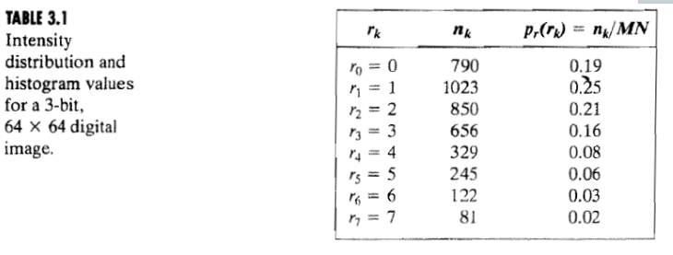

Illustrate the a) original histogram b) Transformation function c) equalized histogram.
6
(6a) What is spatial filtering? Why filtering is needed in image processing? (4)

(6b) Explain the mechanics of linear spatial filtering using 3x3 filter mask. (6)

NU BOARD FINAL SOLVE

NU BOARD FINAL - 2021
1
(1a) Define digital image processing. Write some applications of digital image processing. (6)

(1b) Write down the fundamental steps in digital image processing. (6)

(1c) Describe histogram equalization. (4)

(1d) Explain image sampling and quantization. (4)

2
(2a) Define sharpening and smoothing image. (2)

(2b) What is image restoration? Explain the model of image restoration process with diagram. (6)
(2c) Define probability density function. Briefly discuss Gaussian, Exponential and Gamma noise function. (7)
(2d) Explain different mean filtering methods for image restoration. (5)

3
(3a) Define image enhancement. (4)
(3b) Write down the basic steps for filtering in frequency domain. (6)
(3c) Describe image degradation process. (5)
(3d) Mention the spatial and frequency properties of a noise. (5)

4
(4a) What do you mean by color model? (4)

(4b) Define HUE, Saturation and Luminance. (6)

(4c) Explain homomorphic filtering in details. (6)

(4d) What is masking? (4)

5
(5a) Describe image compression: (7)
Draw an image compression system.
(5b) Explain lossy predictive coding. (5)
(5c) What do you mean by edge detection? (4)
(5d) Define aliasing. (4)
6
(6a) What is image segmentation? (4)

(6b) Explain the region growing segmentation with example. (6)

(6c) Discuss about Huffman coding with a proper example. (6)

(6d) Describe image negative. (4)

End Page (quick rough)

